Y- Lift your arms up in a "Y" shape (with your thumbs pointing backwards), pulling your shoulders back without arching your back.
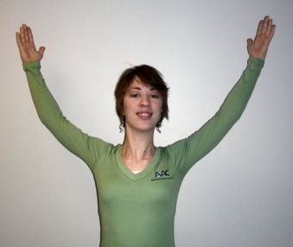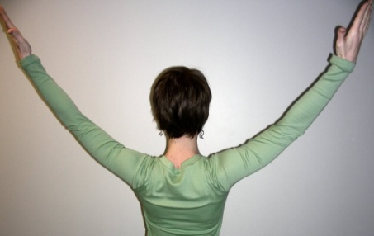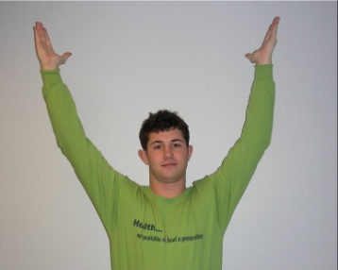
W- From the "Y" position, bring your elbows down until your arms form a "W" shape. This will bring your shoulder blades even closer together (thumbs still pointing back).
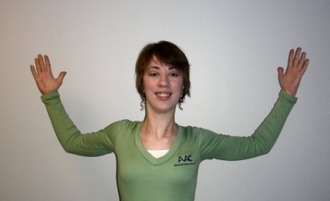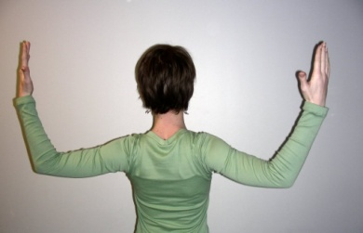
T- From the "W" position, straighten your arms so that they are flat out from your shoulders forming a "T." (Feel the muscles down the center of your upper back contract even more.) Keep your hands flat, palms upwards toward the ceiling.
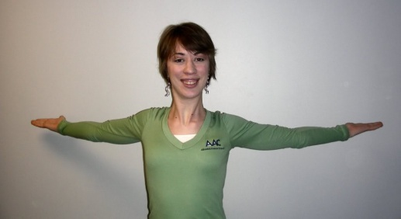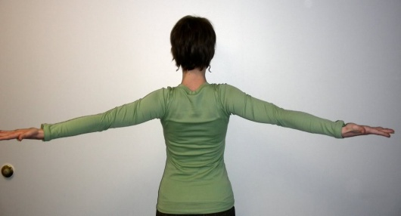
L- Finally, bring your elbows down from the "T" position so that each arm forms an "L" shape coming out from your body at a 90 degree angle. Keep your palms up. This position will bring your shoulder blades very close together.
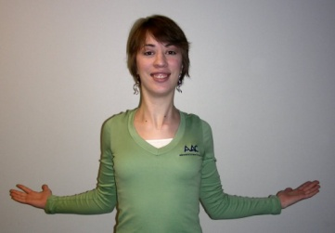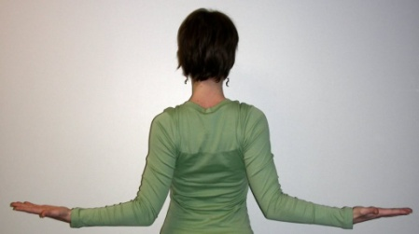\
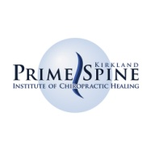PrimeSpine Chiropractic Center | Kirkland,WA | 425 825 8750

